**Microprocessor Lab**

Laboratory Activity No. 2

**Arduino and Tinkercad Interface**

|  |
| --- |

Score

*Submitted by:*

**Sumang, John Angelo C.**

**Saturday 1:00pm-4:00pm/ BSCpE 0412.1-2**

*Date Submitted*

**30-09-2023**

*Submitted to:*

**Engr. Maria Rizette H. Sayo**

I. Objectives

This laboratory activity aims to implement the principles and techniques of hardware programming using Arduino through:

- creating an Arduino programming and circuit diagram.

II. Method/s

- Perform a task problem given in the presentation.

- Write a code and perform an Arduino circuit diagram of a ring counter that display eight (8)LEDs starting from left.

III. Results

**TinkerCad**

**Exercise 1: Write a code that does a ring counter display for eight (8) LEDs starting from left.**

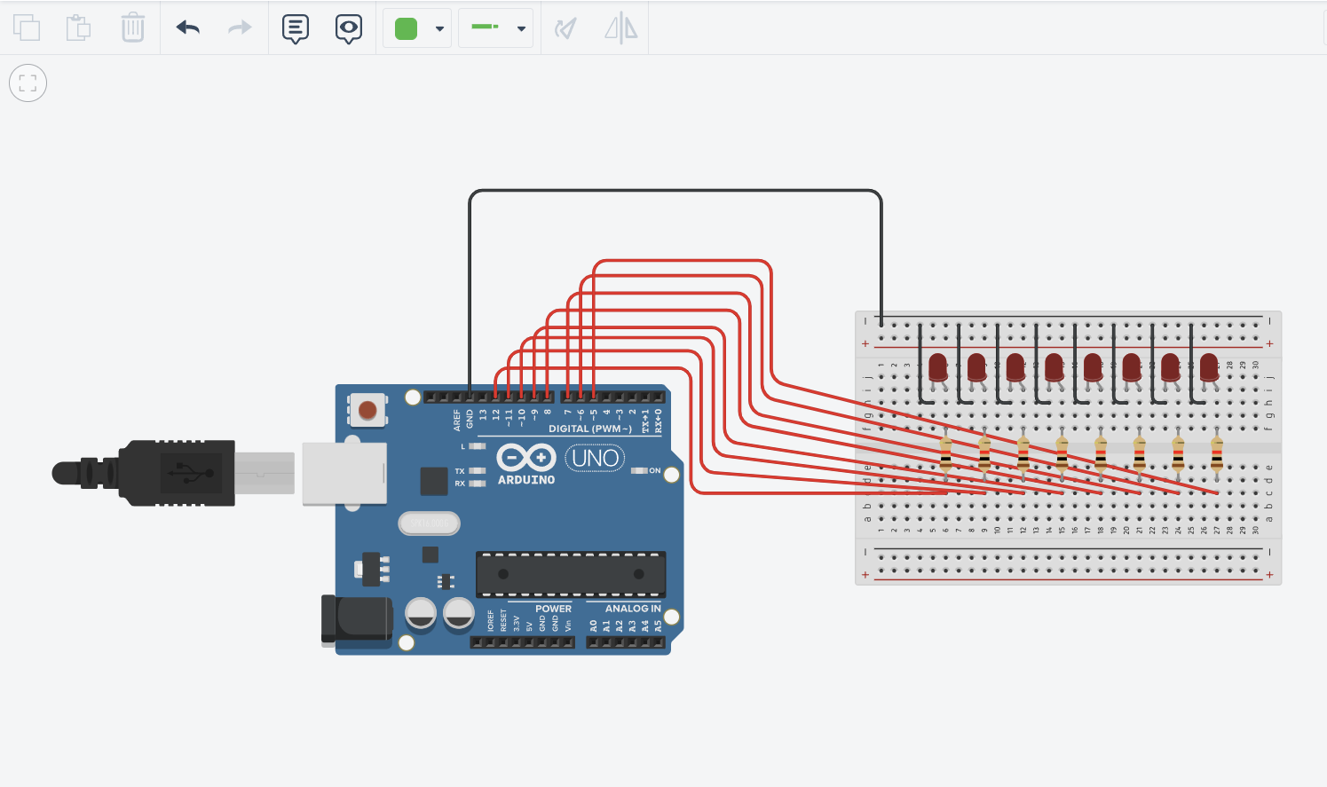

Figure No.1 Ring Counter Display Circuit Diagram

**Components Used**

1. 8 LEDs
2. Resistor
3. Breadboard

**CODE:**

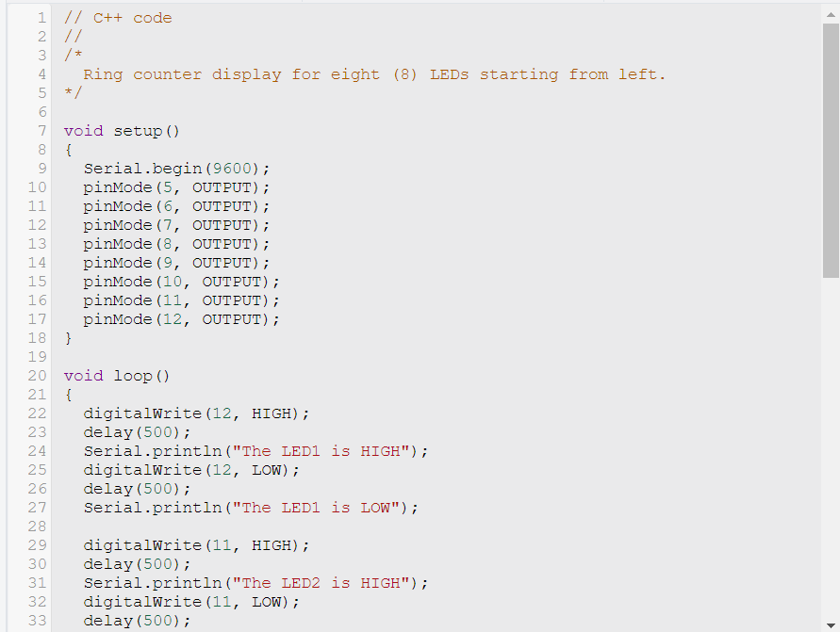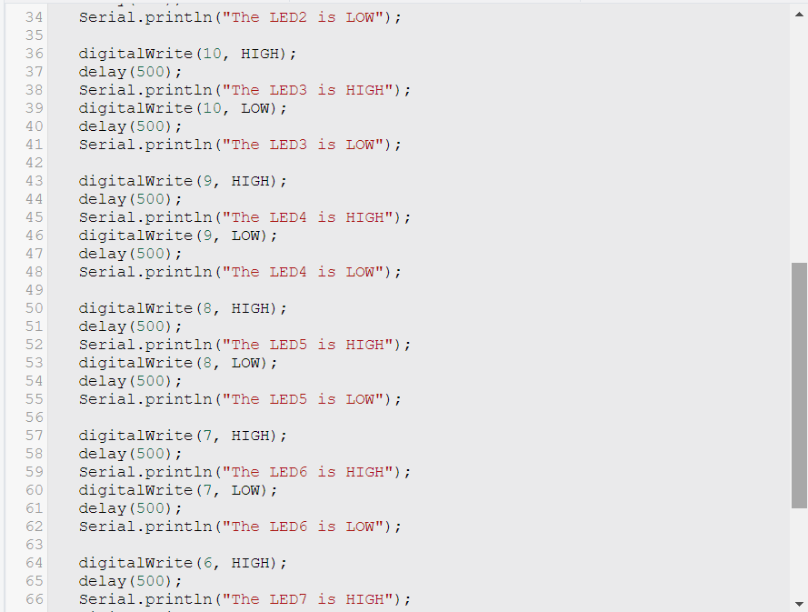

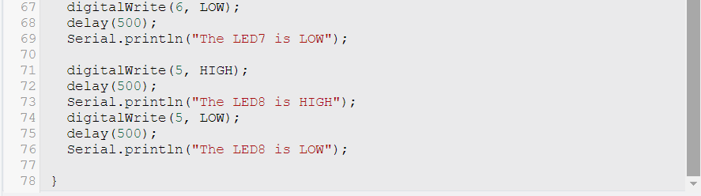

**TinkerCAD Implementation**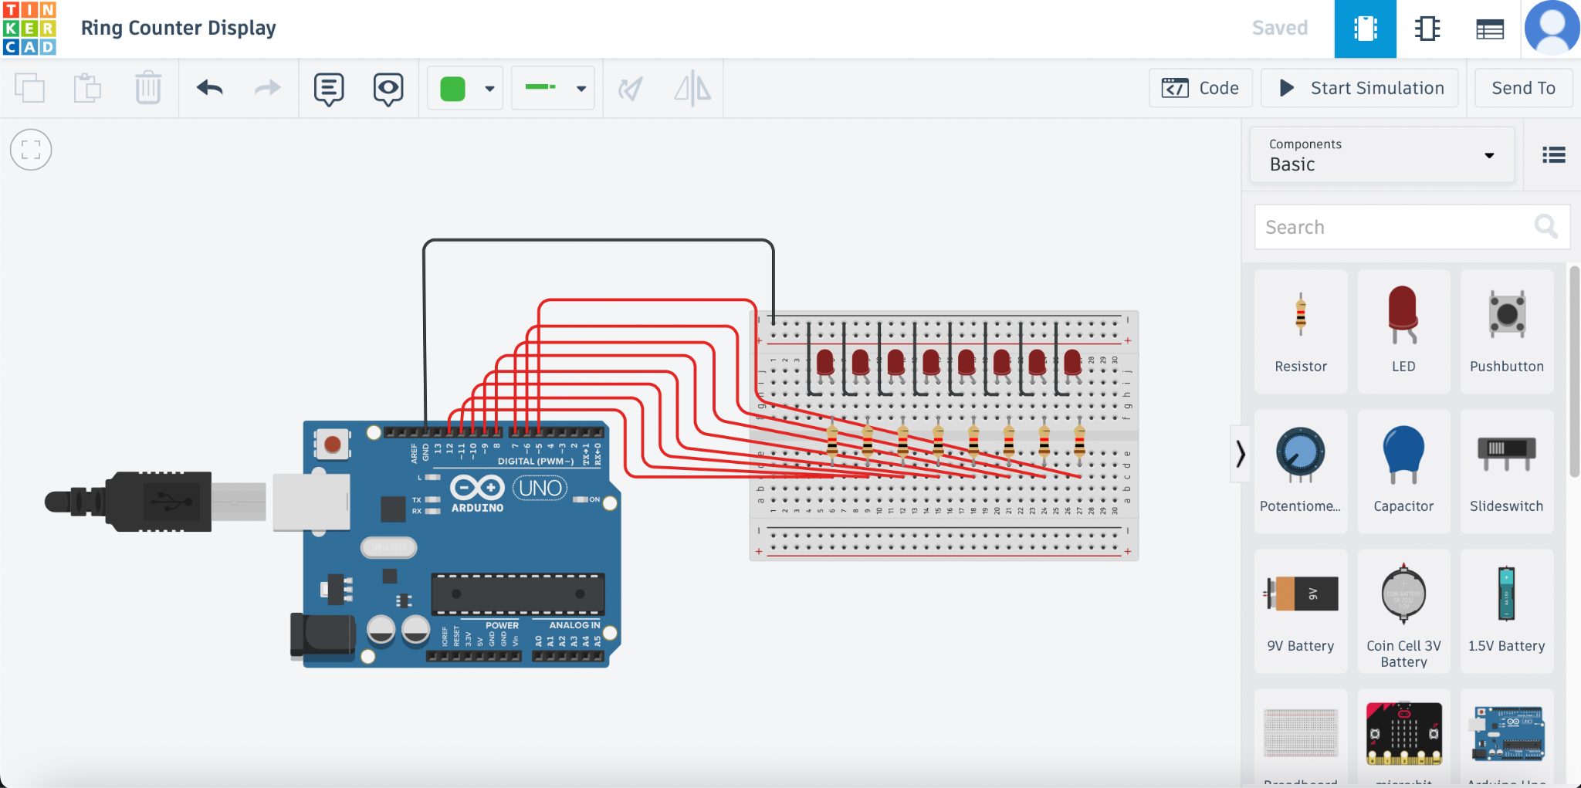

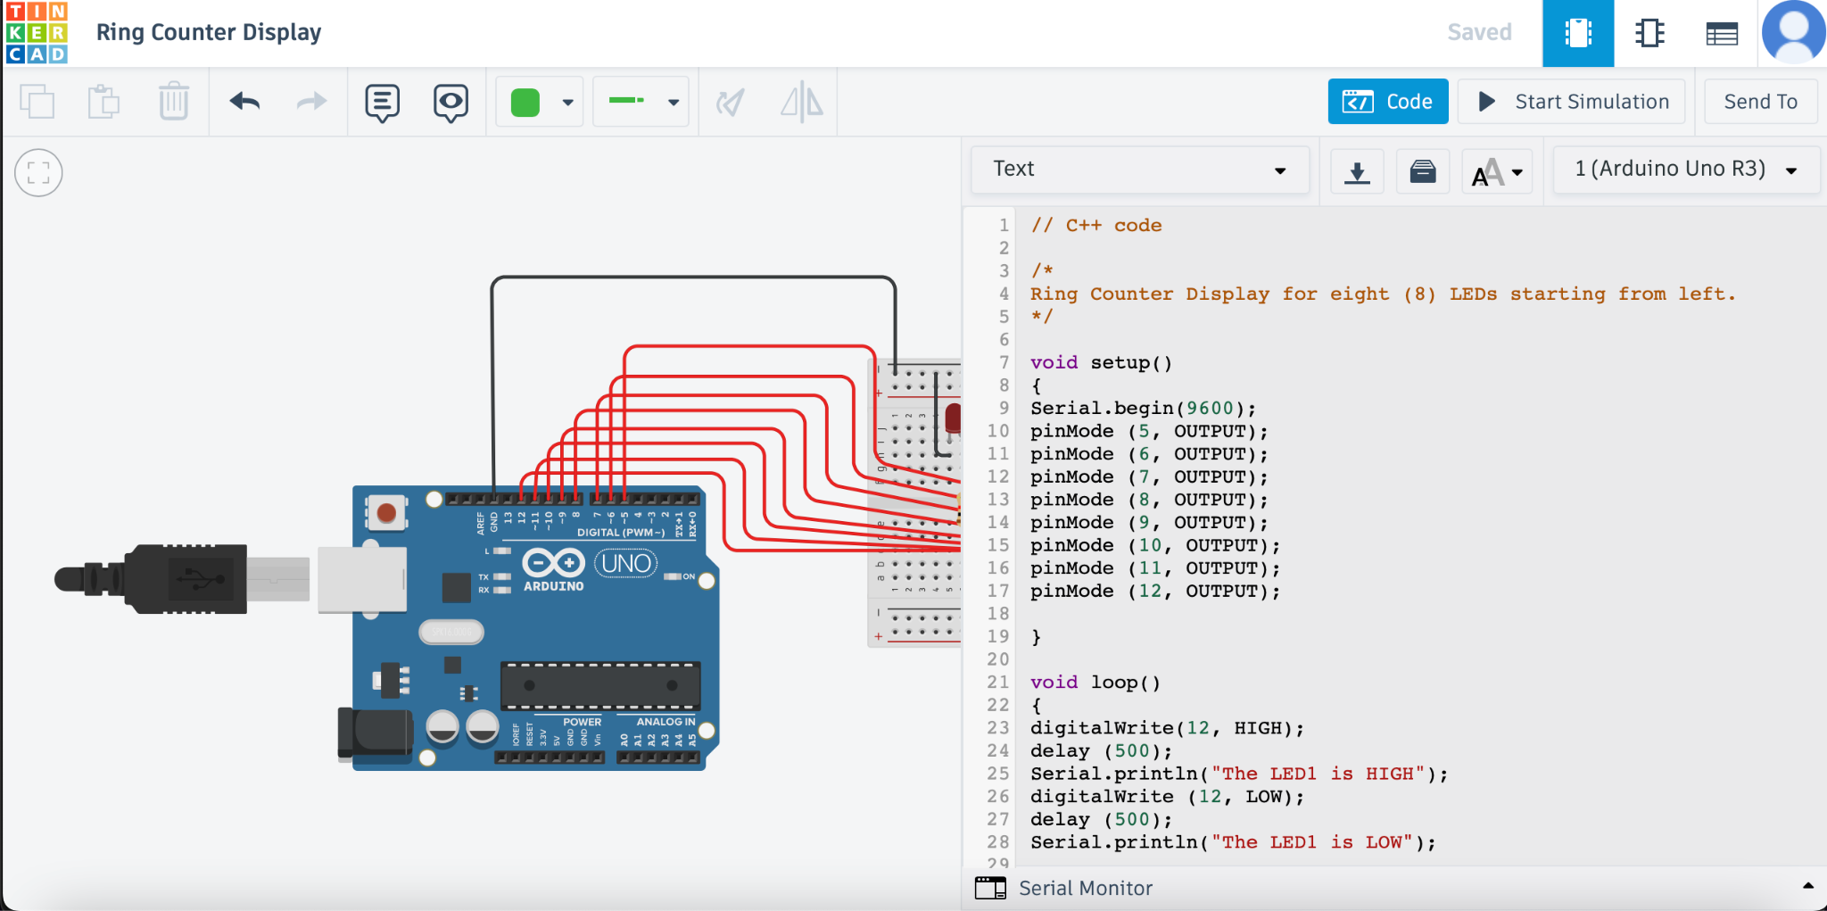

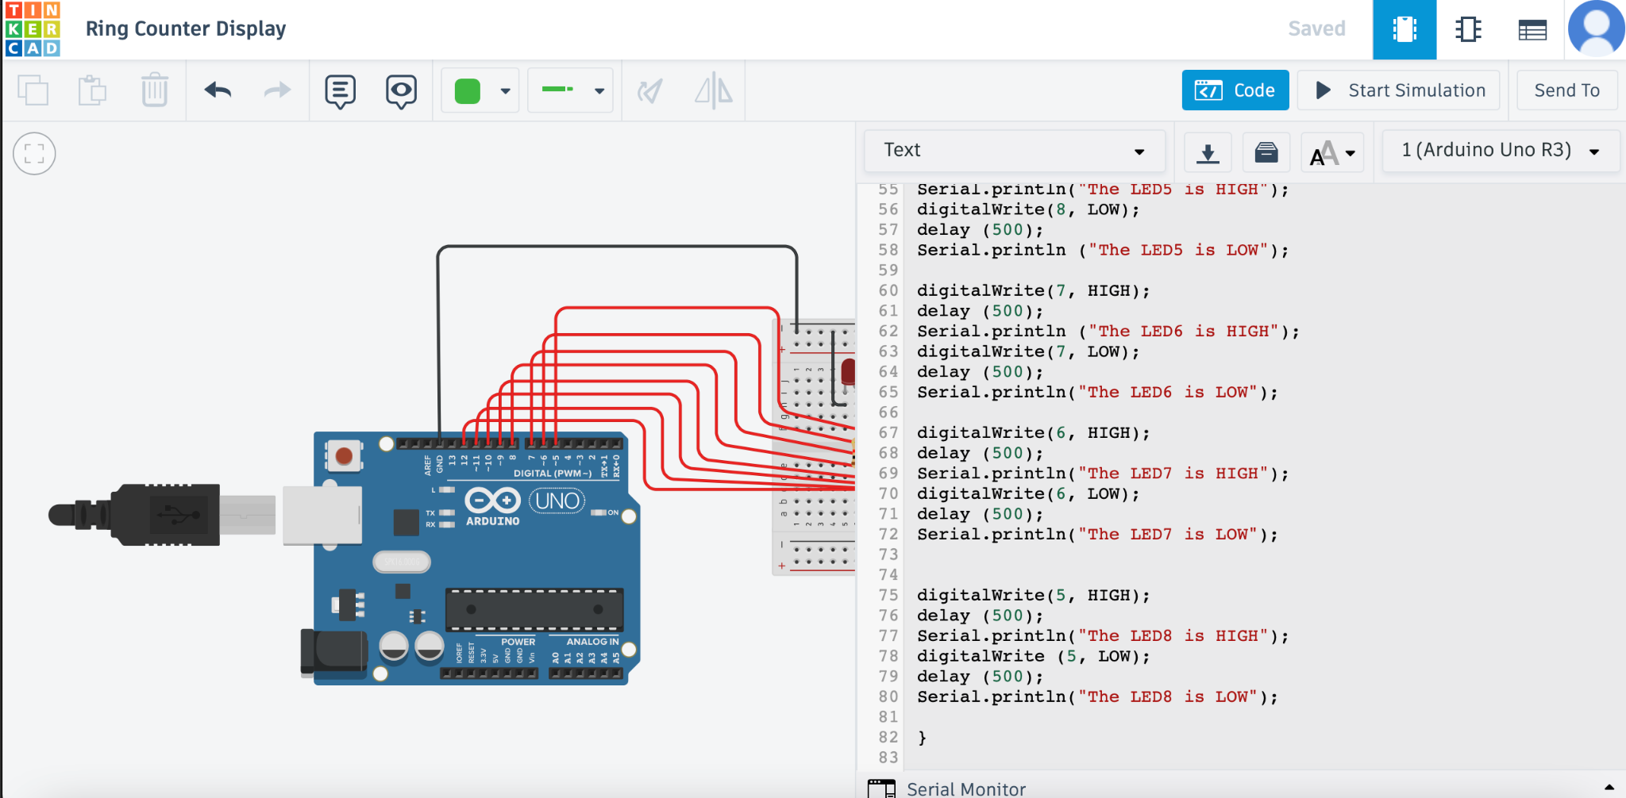

**Simulation**

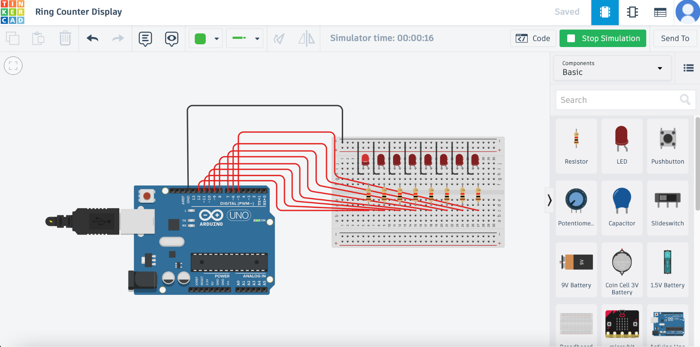

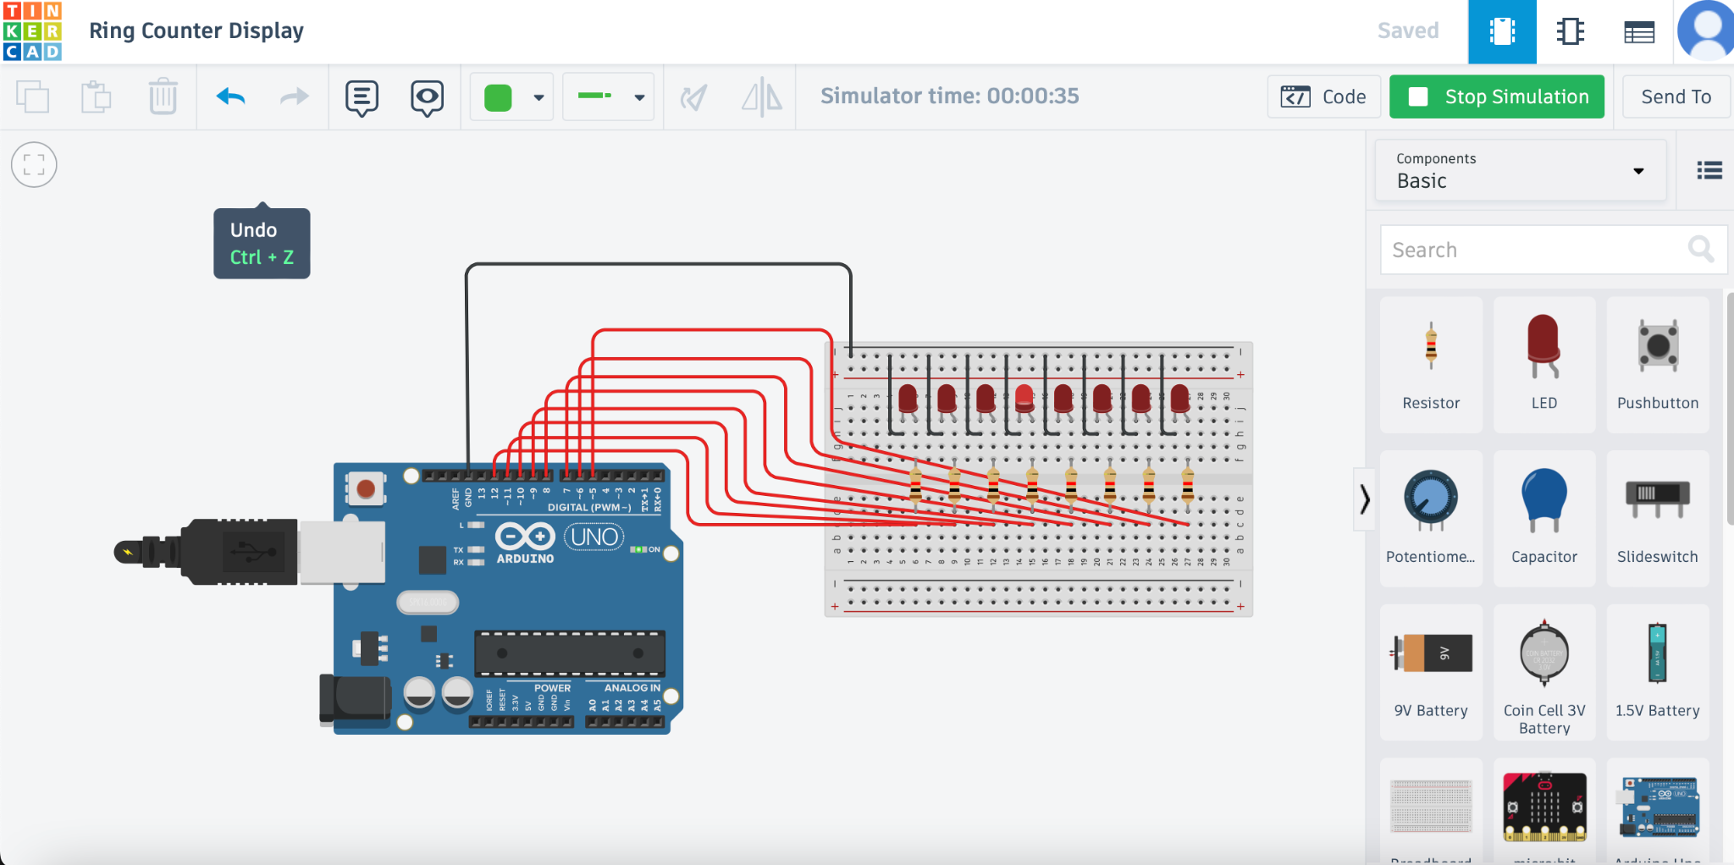

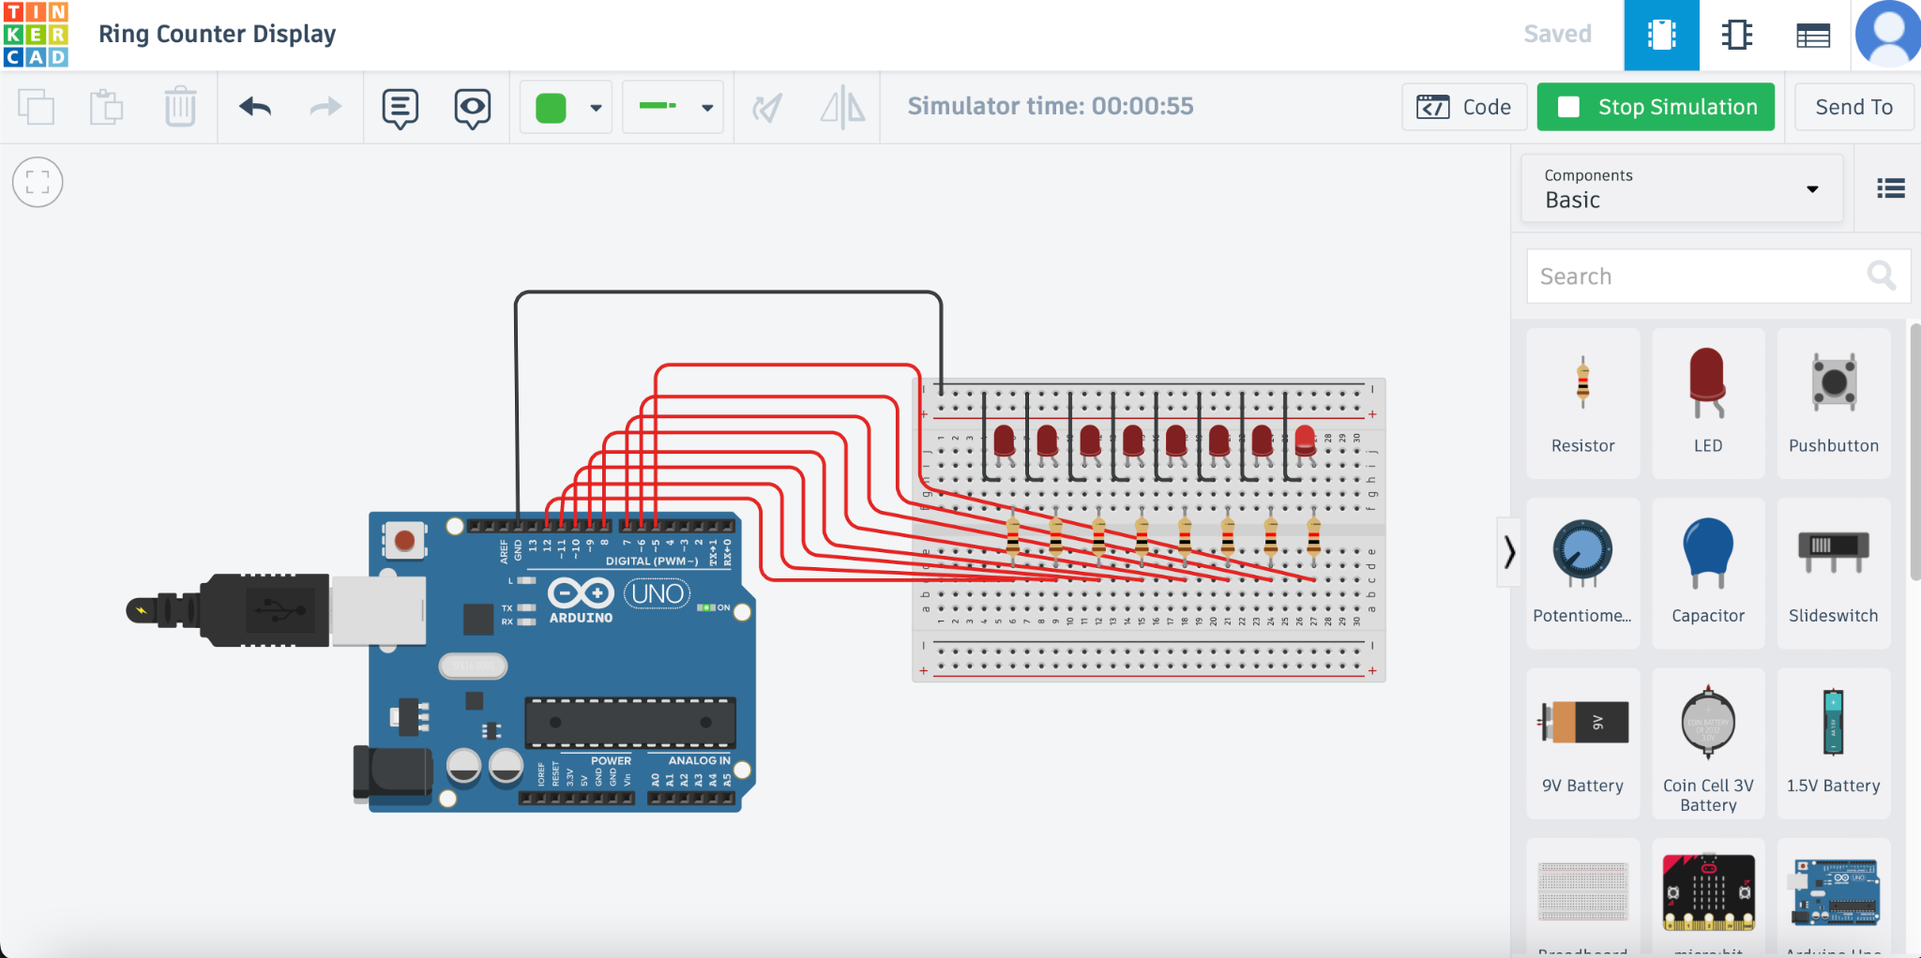

IV. Conclusion

The ring counter for eight (8) LEDs starting from the left has been implemented through the use of TinkerCAD. In the initialization, the output of the last shift register to the first shift register input, and circulated a single one bit around the ring of the LEDs, has been executed. Hence, the number of states in a straight ring counter is equal to the number of flip-flops used. As the output of the last flip-flop is connected back to the input of the first flip-flop, this bit pattern rotates within the counter by shifting its position once for each clock pulse, coded as 'high' or 'low' to determine the corresponding waveforms. Subsequently, the structure of the circuit diagram has been formed by connecting the output of the last flip-flop to the input of the first flip-flop, through the eight LEDs.

**References**

[1] D.J.D. Sayo. “University of the City of Manila Computer Engineering Department Honor Code,” PLM-CpE Departmental Policies, 2020.